**Software Engineering**

**(SE 225)**



Assignment #2:

*Extreme Programming*

*(Test Driven Development - TDD)*

Course Instructor: Mr. Ahmad Mohsin

Student Name: Muhammad Omer Affan

Roll #: 153157 &

Student Name: Syed Arham Gillani

Roll #: 153165

#### Requirements

1. Factorial calculates the multiplication of the all positive numbers less than or equal Target Number(n).
2. Target Number(n) is a non-negative integer.

*First step: Input validation!*

To make sure whatever input the user enters, accept only POSITIVE INTEGERS and nothing else…

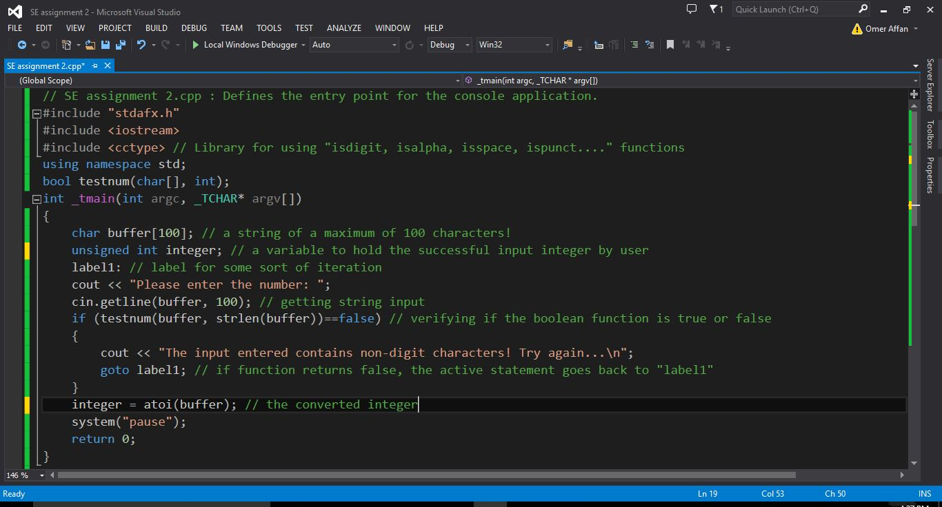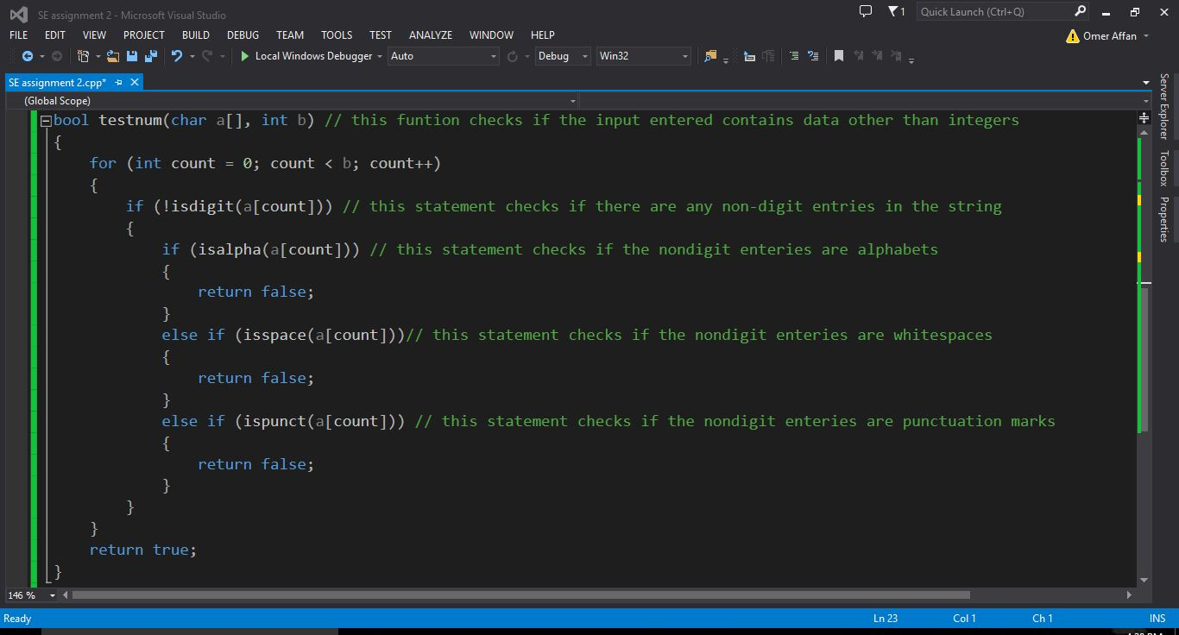

Test inputs and results…

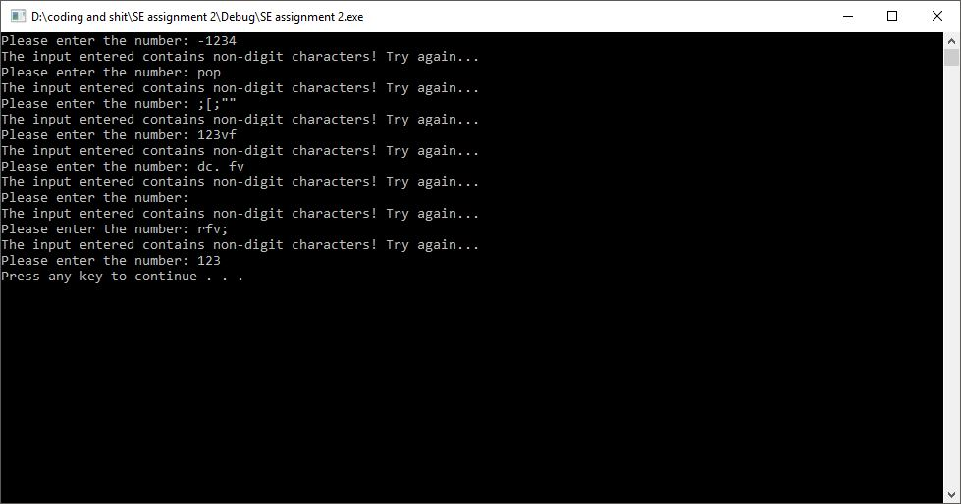

*Second step, unit testing*

TEST# 1:  
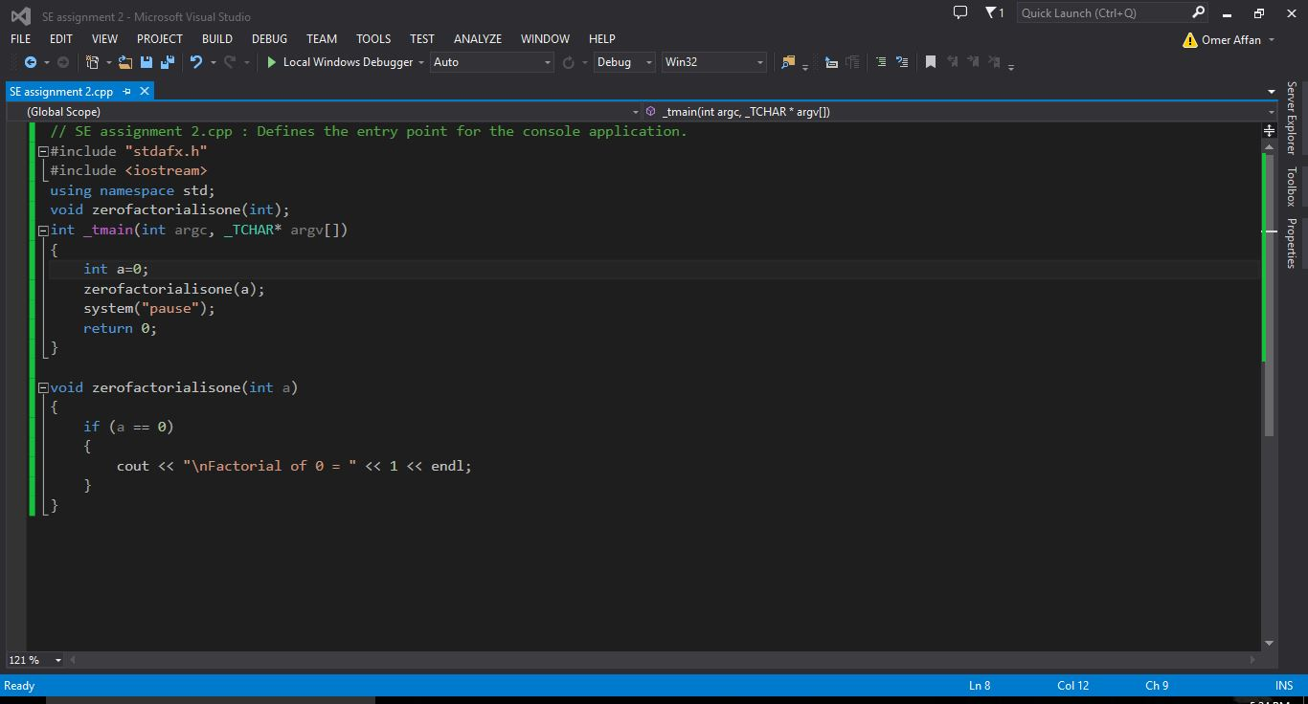

Result

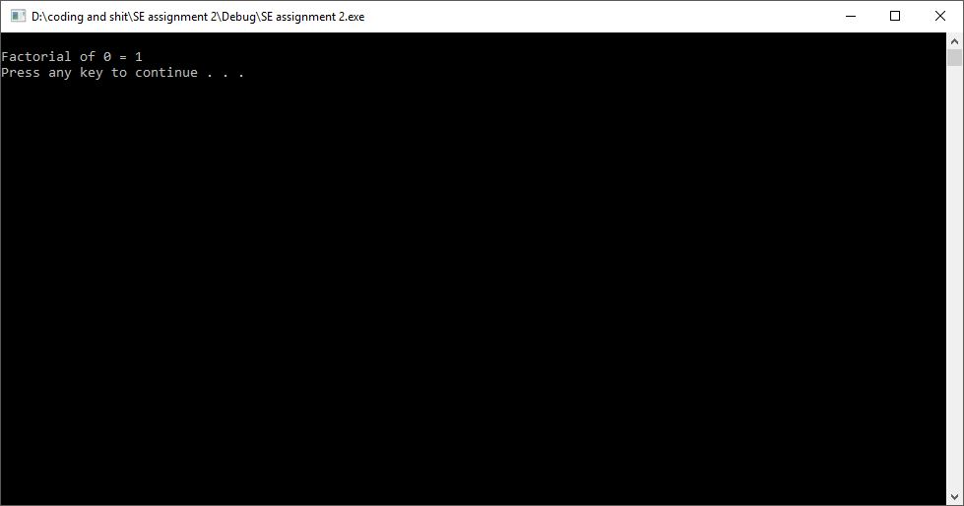

TEST# 2:

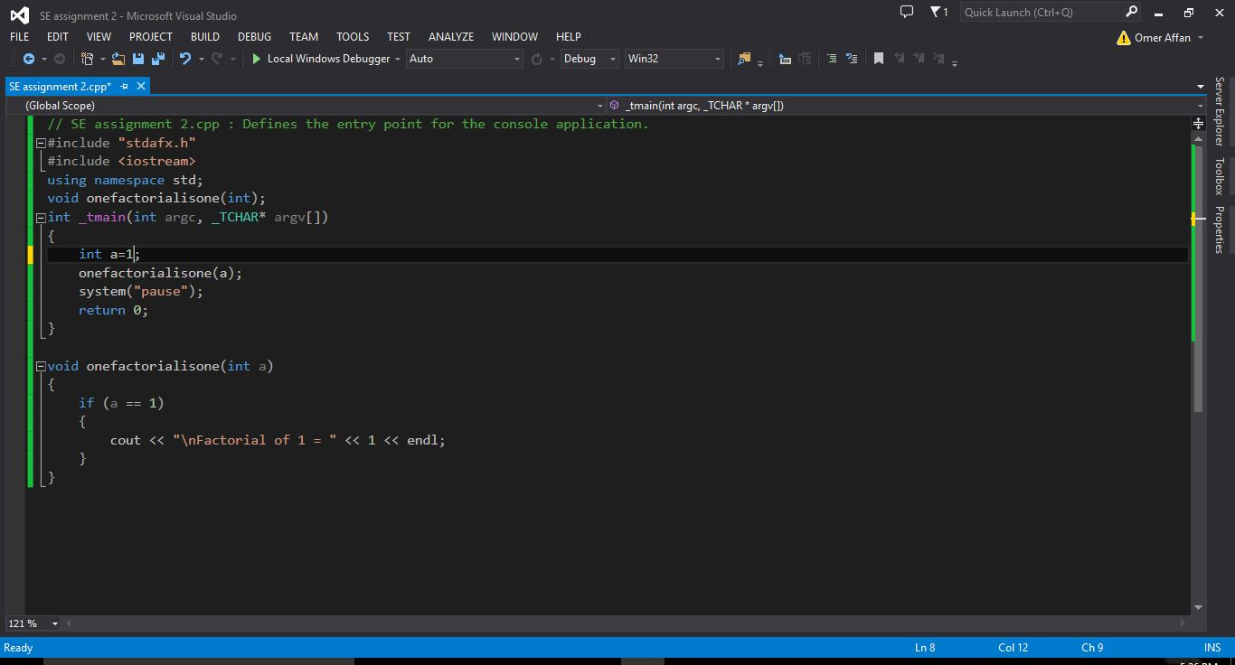

Result

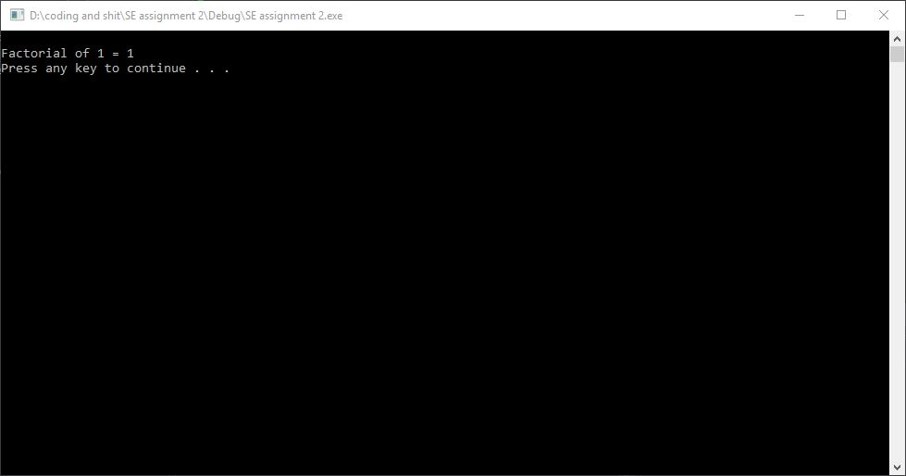

TEST# 3: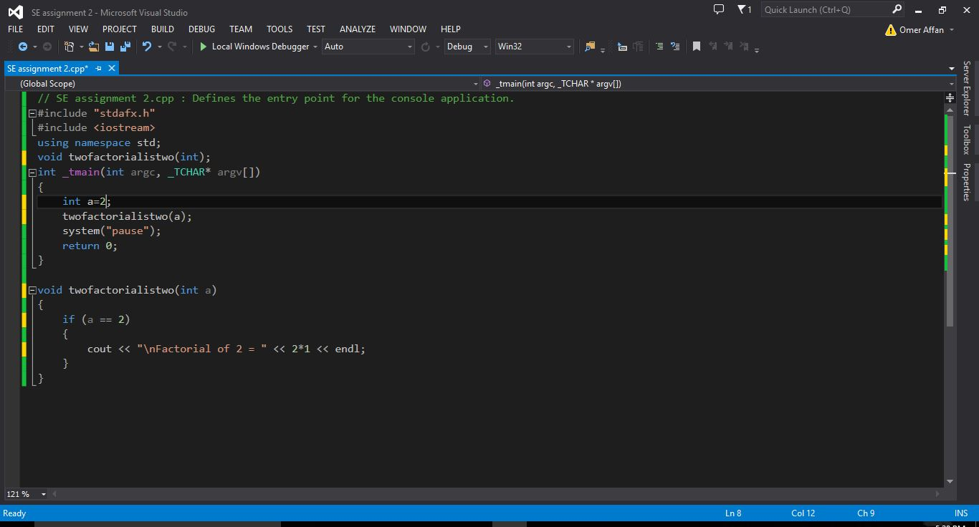

Result

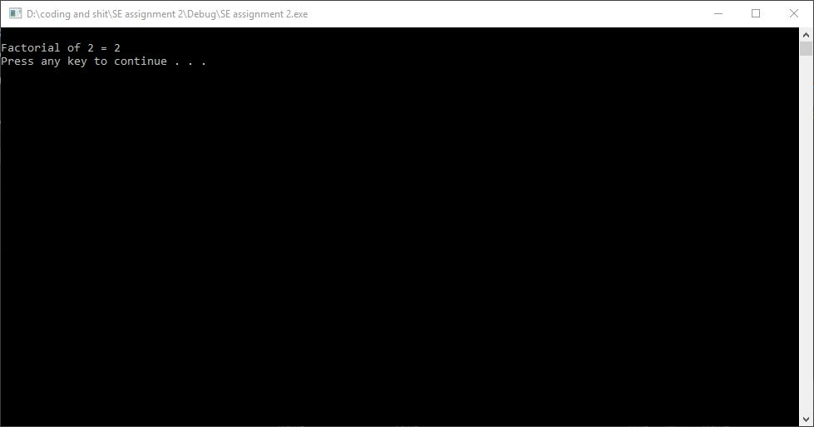

Test# 4:

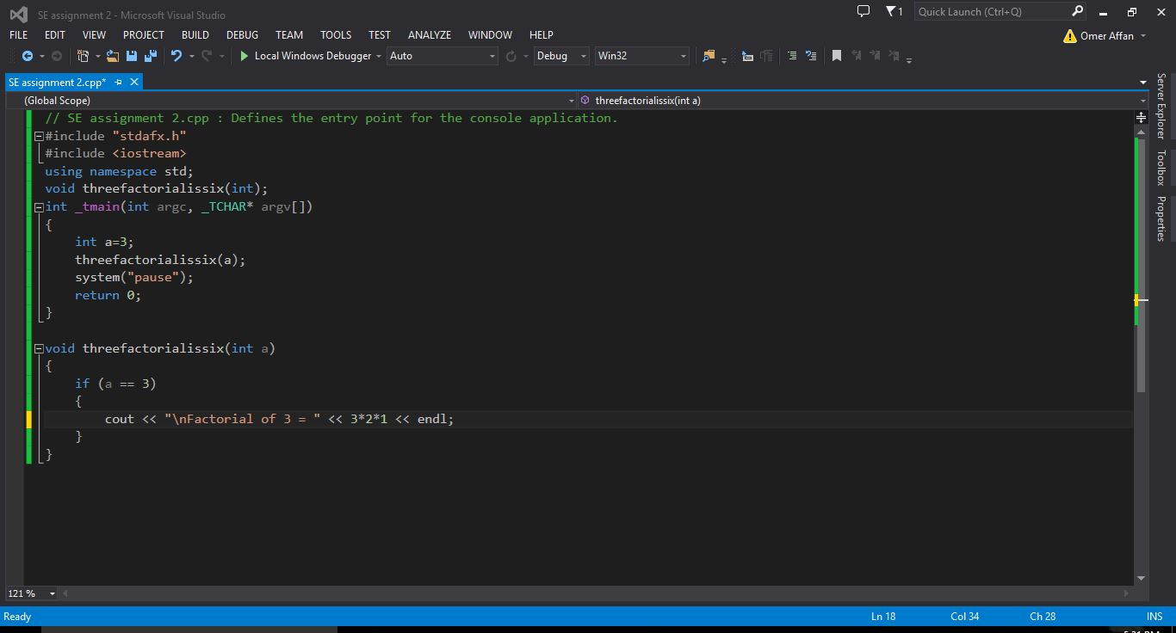

Result

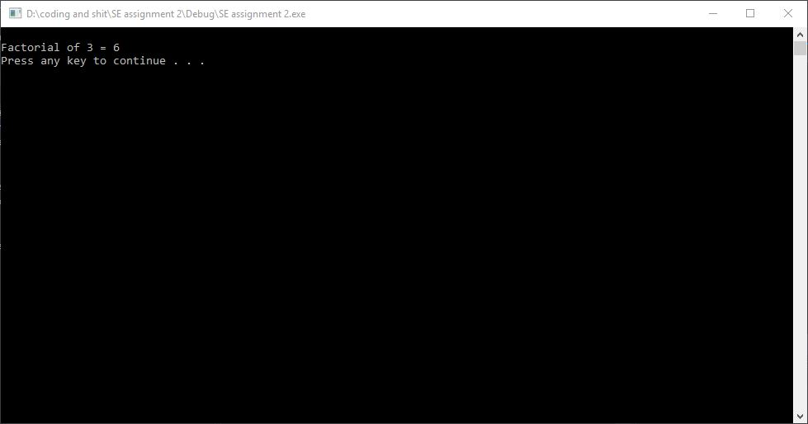

Test# 5

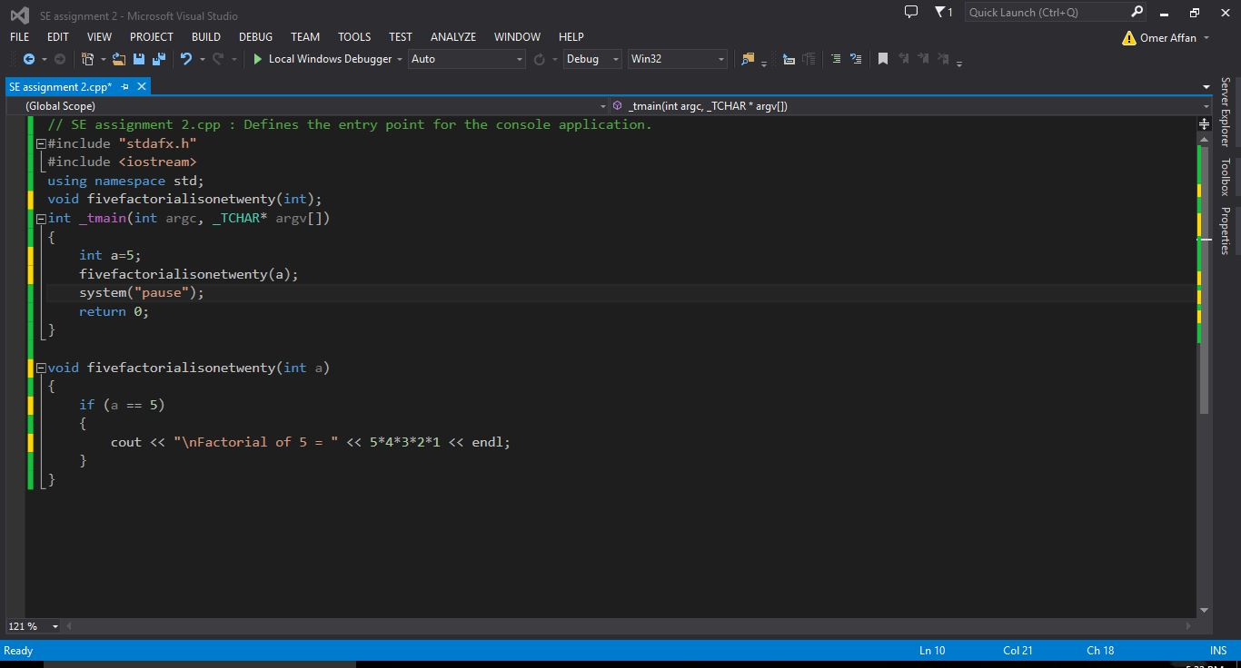

Result

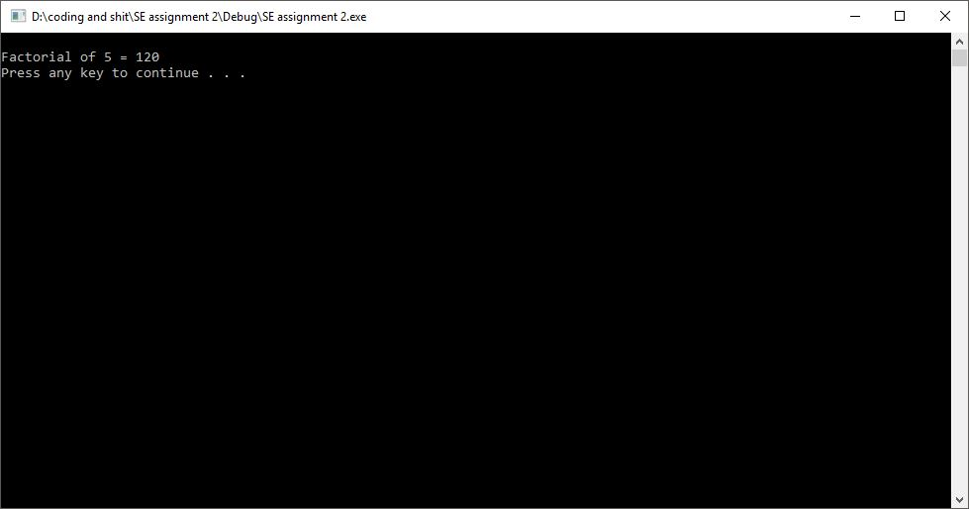

Testing formula for factorial:

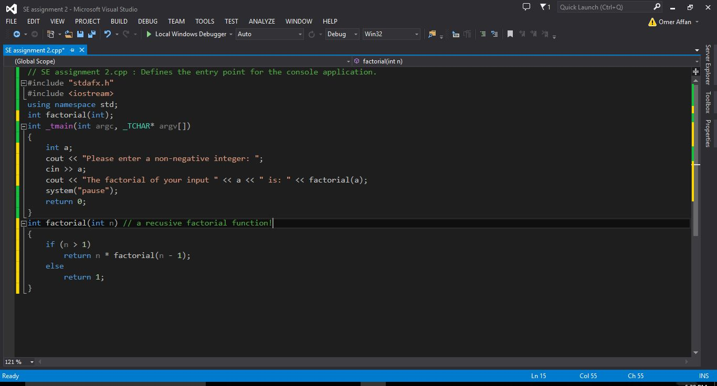

Sample input & Result

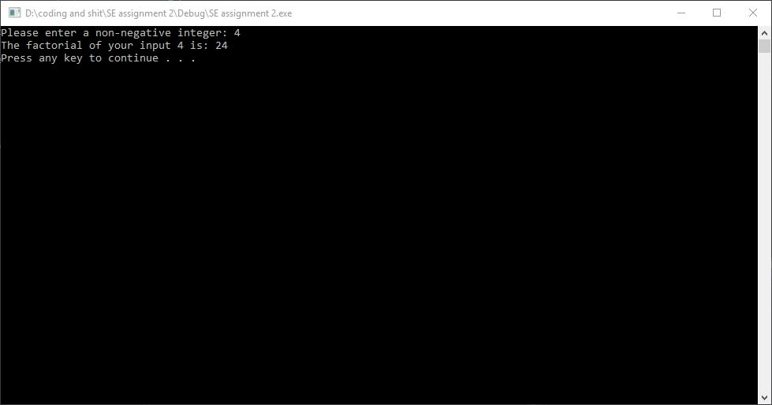

Testing Factorial Results with the derived formula

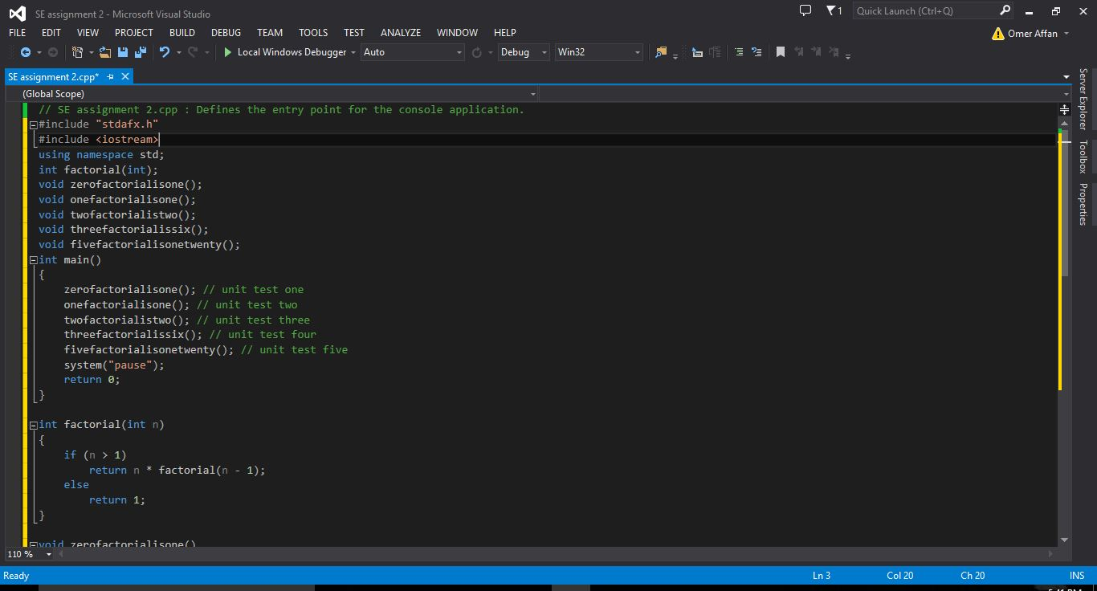

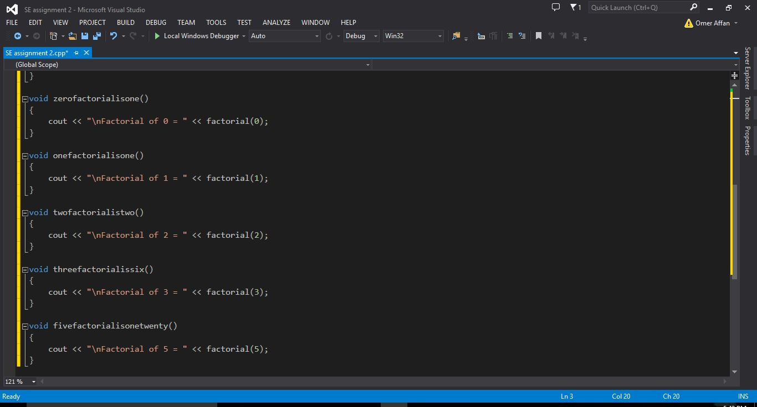

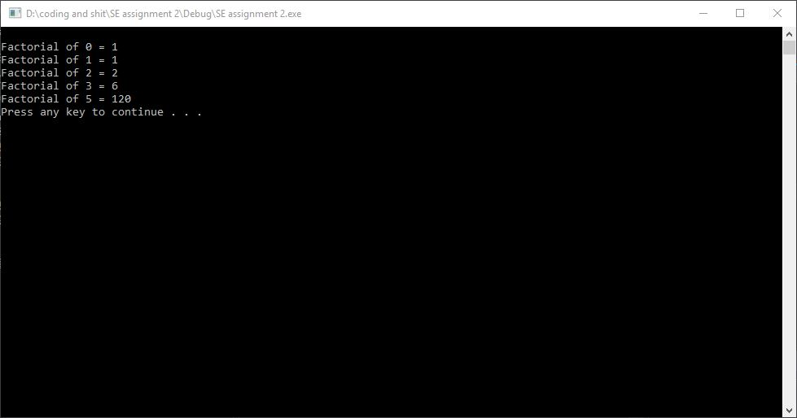

Final Code:

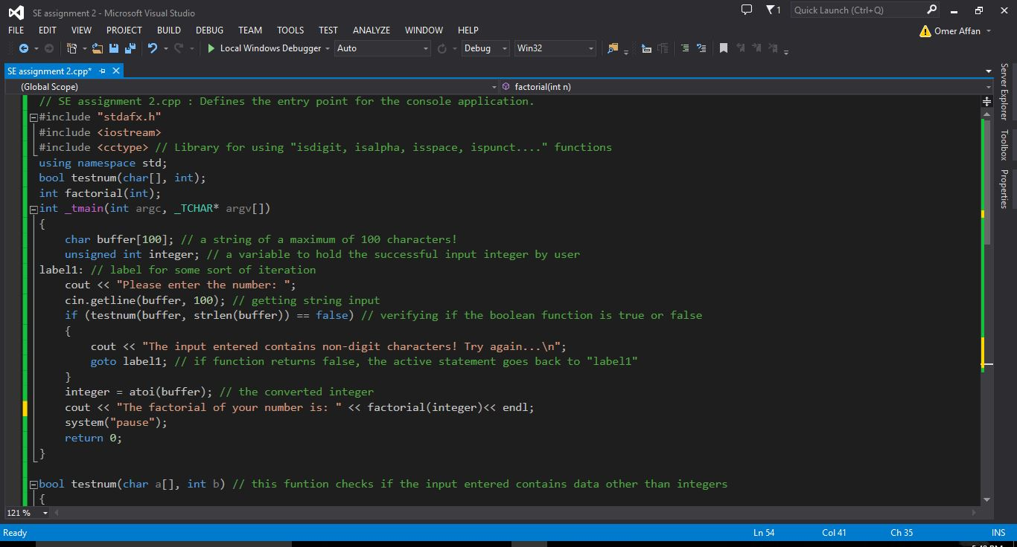

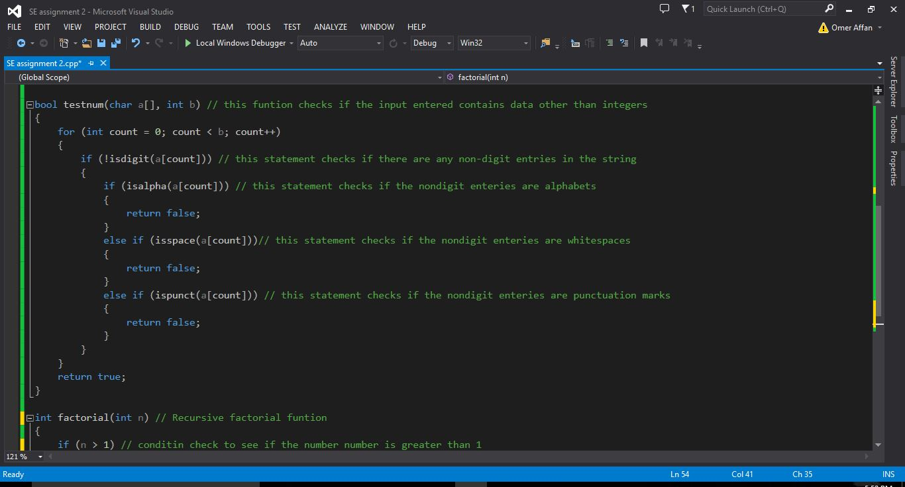

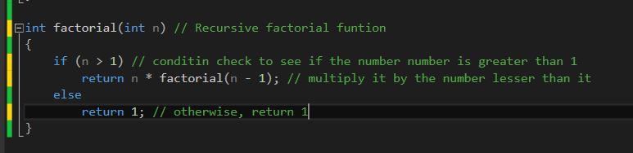

Sample Inputs and Outputs:

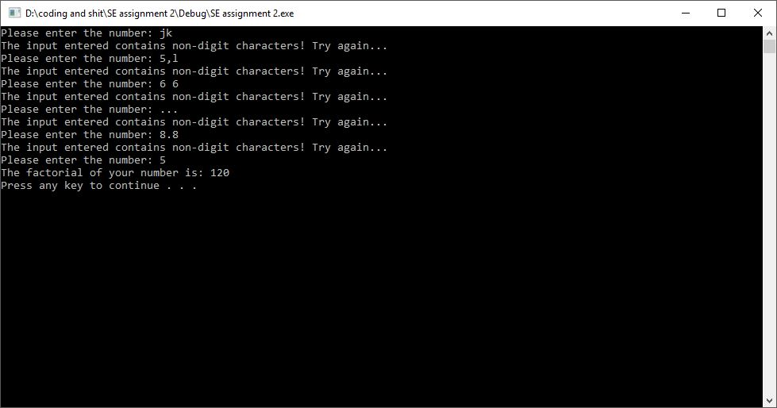

***Approach used to meet the requirements:***

TDD via Pair Programming

Navigator: Arham Gillani  
Programmer: Omer Affan